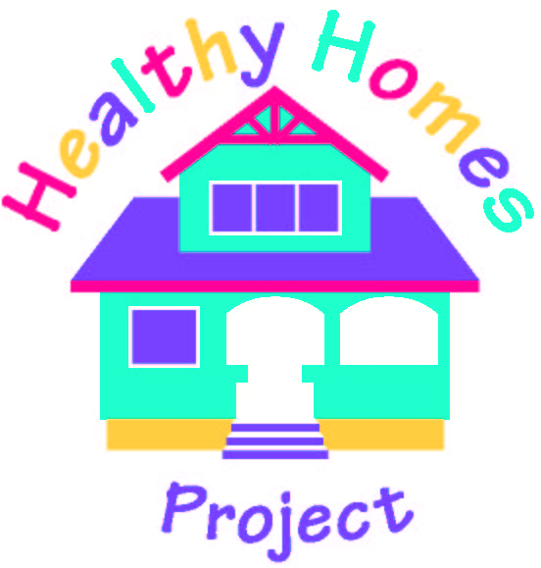
Alameda County Healthy Homes Project
(A Project of the Alameda County Lead Poisoning Prevention Program)

Client: _______________________________ Project # ______________

I. The basic allergen-reduction treatment and injury-prevention services for your home will include the following:

Complete unit vacuuming with a HEPA-filtered vacuum cleaner.

Wet cleaning of hard-surface floors.

Application of The Ecology Works Dustmite and Flea Control powder mixed with water on
carpeted surfaces to eliminate dust mites and fleas (if there are any).

Application of The Ecology Works Anti-Allergen Solution on all upholstered
furniture to neutralize allergens such as dust mites, cockroach allergen and pet
dander.

Application of boric acid powder (not included with your Kit) under and behind
the refrigerator and stove to control pests.

Installation of dust mite-proof mattress cover and pillow case cover on your child’s bed to reduce
exposure to dust mite allergen.

Cleaning of refrigerator coils and drip pan to reduce pest habitability.

Installation of _____ smoke detector(s) in _______________________________________.
(location)

Installation of fire extinguisher in or around the kitchen area.

II. The following additional services will only be provided as needed:

Mold removal from cleanable surfaces. Location: _________________________

Heater vents cleaning. Location: _______________________________________

Exhaust fan cleaning. Location: ________________________________________

Healthy Homes Community Specialist: _________________________________

Date: ________________________

