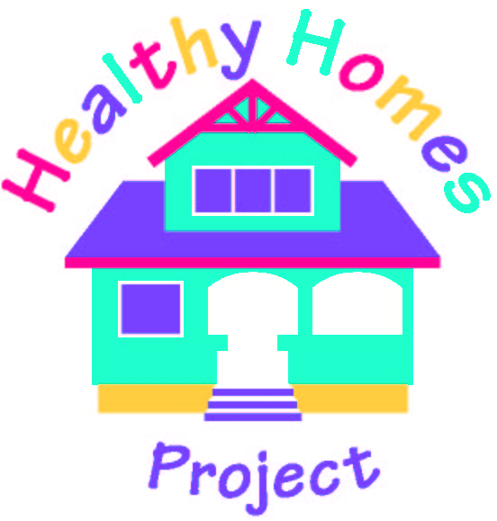
Alameda County Healthy Homes Project
(A Project of the Alameda County Lead Poisoning Prevention Program)

Initial Visit Task List

A. At participant’s home:

1. Introduce yourself and the Project.

- Name/business card/badge
- Title
- Permission to enter
- Reason for visit
- Project overview/objectives/purpose and visit agenda*

* For example: “The Healthy Homes Project is funded by the US Department of Housing and Urban Development. Our goal is to decrease asthma symptoms in (child’s name) by improving the environment in your home. The Healthy Homes Project offers free allergen-reduction services and minor repairs to improve ventilation, if needed, as well as educational visits to discuss what makes (child’s name)’s asthma worse and injury-prevention tips. With your participation in the Project, you also receive the gift of a Healthy Homes Maintenance Kit with a vacuum (or mop and bucket), mattress and pillow covers to reduce allergen exposure, a fire extinguisher, plastic food containers, and array of cleaning products, and many more health and safety items.”

2. Ask participant to sign Agreement to Participate and Consent to Release Patient Medical Records forms.

3. Fill out Occupant Information form (for referral to weatherization services) together with the participant.

4. Perform visual inspection using the Visual Assessment Checklist, take photos as needed, and measure hot water temperature ( _________ F ).

5. If exhaust fan installation or minor repairs are needed (CESC intervention), then ask participant to sign Occupant Consent to Contact Property Owner. (Participant may prefer to contact owner personally.) Also, advice participant that scheduling the housing intervention might take up to a month if minor repairs are needed.

6. Take dust sample. Two minutes at each location (five locations)

- In the bedroom – upper mattress surface and floor area next to the bed
- In the living/family room – floor and upholstered furniture
- In the kitchen – floor, especially corners and ledges

7. Set out Radon test in lowest livable area of the home, such as family room. See test instructions for details. Make sure to record the Serial Number Test Kit and fill out the form together with participant.
Test kit Serial Number: __________________________

8. Conduct Behavior-Health Assessment and Initial Questionnaires of the Asthma Knowledge Survey and Injury Knowledge Survey. Fill out first row on the Monthly Asthma Severity and Injury Assessment Survey at the participant’s home to use as baseline.

9. Go over [Client] Training Curriculum.

- What is Asthma? - Healthy Homes Maintenance Kit
- Asthma Management and Control - Lead Poisoning Prevention
- Asthma Triggers and Prevention - Mercury in the Home
- How to Maintain a Healthy Home - Radon Exposure Prevention
- Safety and Injury Prevention

10. Remind participant about bi-weekly phone calls to monitor and track asthma severity and injury assessment scores, and ask about preferred times for allergen-reduction treatment services.

11. Remind participant to mail Radon test in 2 days (no more than 3) using the self-addressed stamped envelope. Also, advise to keep the HH Maintenance Kit intact until Manos or CESC arrive for the allergen-reduction treatment, and to remove, prior to intervention, any clothing/boxes inside closets if mold clean up is required. Do not place closet items on bed since Manos will also need to put the mattress/pillow covers. This is a one-time allergen-reduction treatment service and not an on-going house cleaning service.

12. Thank participant for taking part in the Project.

*** 6-month follow-up visit uses the date of allergen-reduction treatment intervention as a starting point. Biweekly phone calls should be scheduled after education intervention.

B. At the office:

1. Determine referrals needed and assist in scheduling housing interventions, IPM treatments and weatherization services.

2. Fill out the Chain-of-Custody form for the lab (EMSL Analytical, Inc. dba LA Testing), make a copy for filing, and mail dust sample using a pre-paid FedEx label. Ideally, wait until about 10-15 samples have accumulated to mail them together. In the meantime, keep them in freezer, separate from the QA samples.

2.a. Every 10th customer sample should be followed by a Quality Assurance (QA) sample from the Project’s stock found in the freezer in the break room.

3. If CESC intervention is needed, contact property owner and introduce yourself and the Project. Get a verbal consent to participate, and advise them that the Project HHCS will be sending a consent form for CESC. Send the Release from Liability and the Owner Consent Form to the property owner and fax a copy to CESC for their records.

4. Send the Work Authorization form and customized Scope of Work document to either Manos Janitorial Cooperative (only by fax), followed by regular mail. Make a copy of the originals for filing. Make sure to specify under “Preferred times/Other notes” whether the participant has pets and if they received a vacuum from the Project or not, among other things.

4.a. For CESC, when the Owner Consent Form is returned by the property owner to the HHCS, send the original forms and the Scope of Work and the Work Authorization and forward to CESC by mail. Also, make sure a copy of the owner’s consent to repairs is in the project folder.

5. For a Referral for Weatherization Services, consult the Energy Partners Income Guidelines. If Client is below Total Combined Annual Income (TCAI), then refer to the City of Berkeley Weatherization Services Department (for Berkeley, Albany and Emeryville residents) or to Richard Heath and Associates (for all other Alameda County residents). If Client is above TCAI, then refer to Rising Sun Energy Center’s (http://www.risingsunenergy.org/programs.htm) Subsidized Attic Insulation Program.

6. Enter all necessary data in the Healthy Homes MS ACCESS database and Housing database (LeadHouse).

7. Check File Check List, make necessary copies (i.e., Chain-of-Custody form, Work Authorization, etc…), and file all paperwork.

8. Make a follow-up phone call to client after receiving Work Authorization back with the “Service Provider certification” portion signed. Verify services were provided satisfactorily and ask if the Radon test was sent out.

9. Process payment for Service Providers? APRehab?

C. Follow-up/Monthly phone call

1. Ask if Manos or CESC has contacted them/performed intervention? If so, are they satisfied with the work?

2. Ask if the Radon test kit was mailed to the appropriate agency.

3. Perform monthly Asthma Severity and Injury Assessment Survey.

