ALAMEDA COUNTY HEALTHY HOMES PROJECT
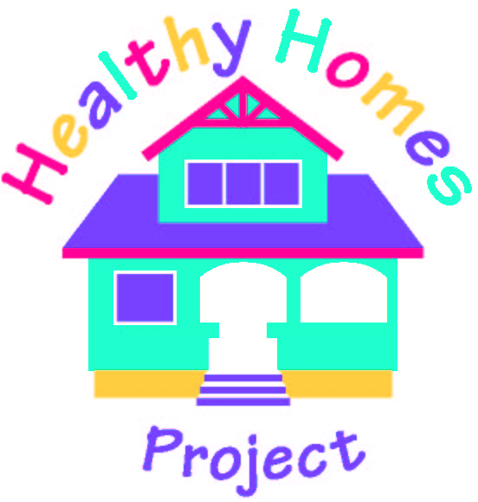
2000 Embarcadero, Suite 300  Oakland, CA 94606  (510) 567-8282
www.aclppp.org

CLIENT SATISFACTION SURVEY

Child’s Name:_______________________ Project #_______________
Date:_______________________

Please answer the following questions on a scale from 1 to 3.
* 1 = Not * 2 = Yes * 3 = Very
(Circle the best answer) DOES NOT

PLEASE ANSWER THE FOLLOWING NOT YES VERY APPLY

1) How satisfied were you with your 1 2 3 N/A
interaction with the Healthy Homes
Community Specialist (home visitor)?

- How helpful were the educational 1 2 3 N/A
messages?

- How useful were the products given to you 1 2 3 N/A
in the Healthy Homes Maintenance Kit?

- What products were most useful? ________________________________________
- What products were least useful? ________________________________________

4) How helpful were the project’s services 1 2 3 N/A
in reducing your child’s asthma symptoms?

- How satisfied were you with the services 1 2 3 N/A
provided by the janitorial and/or minor repairs
contractors?

6) How satisfied were you with the overall project? 1 2 3 N/A

Comments:______________________________________________________________________________________________________________________________________
_______________________________________________________________________
_______________________________________________________________________

/tmp/in/input.doc

