ALAMEDA COUNTY HEALTHY HOMES PROJECT
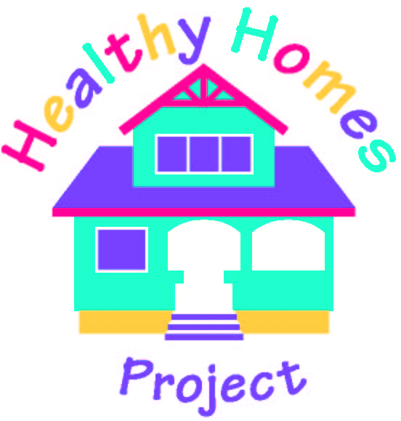
(A Project of the Alameda County Lead Poisoning Prevention Program)

ASTHMA TRIGGERS CHECKLIST

MEDICATIONS |  | ❑ |  | Keep action plan and medications in an easy to find and safe place.
 |  | ❑ |  | Wash spacer and mask weekly.
 |  | ❑ |  | Make sure nebulizer is working properly.
 |  | ❑ |  | Refill medications before you run out.
SMOKE |  | ❑ |  | Do not smoke. Attend classes to help you stop smoking.
 |  | ❑ |  | Do not allow smoking in the home or car.
 |  | ❑ |  | If you smoke, smoke outside and change clothes before returning.
DUST  &  DUST MITES  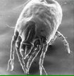 |  | ❑ |  | Vacuum weekly with HEPA-filter vacuum. Make sure your child  is not home when vacuuming.
 |  | ❑ |  | Remove carpet if possible. Wet before removing.
 |  | ❑ |  | Wet mop floors at least weekly.
 |  | ❑ |  | Wash bedding and stuffed toys in hot water (120◦) every 1-2 weeks.
 |  | ❑ |  | Cover mattresses and pillows with dust-proof zippered covers.
 |  | ❑ |  | Reduce clutter and remove stuffed toys.
 |  | ❑ |  | Replace heating system filters monthly during winter.
PESTS |  | ❑ |  | Do not leave food or garbage out. Store food in airtight containers.
 |  | ❑ |  | Try using poison baits, such as boric acid for cockroaches. Place  baits away from children, such as behind refrigerator.
 |  | ❑ |  | Vacuum up cockroach bodies and fill any holes in with copper wool.
 |  | ❑ |  | Fix leaky plumbing/roof or other sources of water.
MOLD  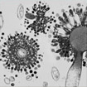 |  | ❑ |  | Use an exhaust fan or open a window when showering or cooking.
 |  | ❑ |  | Clean mold off hard surfaces with water and detergent and dry  completely. Absorbent materials with mold may need to be replaced.
 |  | ❑ |  | Fix leaky plumbing/roof or other sources of water.
ANIMALS |  | ❑ |  | Consider not having pets. Keep pets out of your child’s bedroom.
 |  | ❑ |  | Wash your and your child’s hands after petting animals.
ODORS/SPRAYS  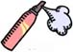 |  | ❑ |  | Don’t use perfume, talcum powder, incense or other strong scents.
 |  | ❑ |  | Do not use stove/oven for heating house.
 |  | ❑ |  | When cleaning, keep child away and don’t use strong smelling cleansers,  including bleach.

